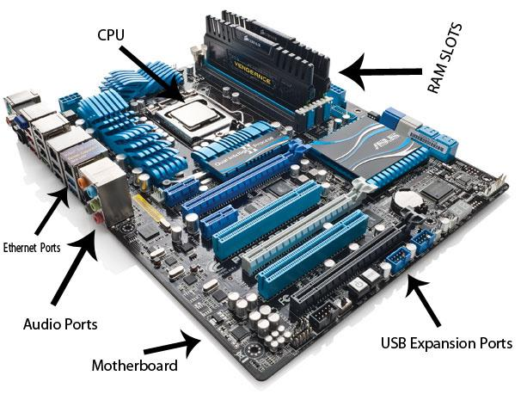

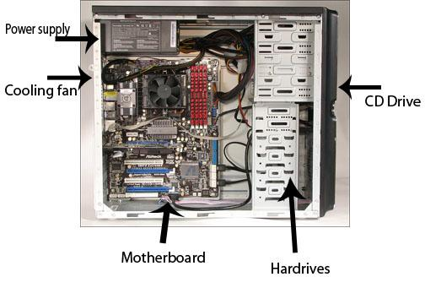

3 a) What different versions are currently available (speed and capacity)

Motherboards come in different configuration such as ATX and Mini ATX